**Ampara district Damana division**

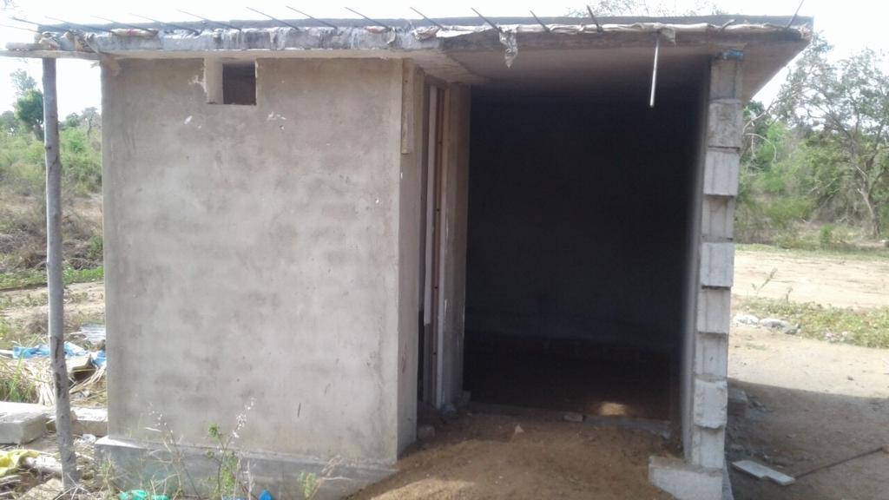

Pokunugala maha viharaya improvement of sanitation facility